

**LETTER OF INTENT**

**Dear ,**

**We value your Skill and Expertise!**

Welcome to the team **TEE**(Team Eagle Enterprises).

The project of **Eagle Entertainment** is Hiring to work with the agreement of One Day salary of **2000rs** (extra expenses included as per your performance your pay might be increased or decreased) and the rules & regulations will Updated by the Team!.

We hope to see you at our premises soon. We are writing this as Intent of Hiring to confirm our discussions about the possibility of your joining.

You’ve been chosen as the standout pick for our team – it’s an exciting opportunity!.

Regards,

Eagle Entertainment,

Erode.

Eagle Entertainment CEO

TEE Entertainment COO

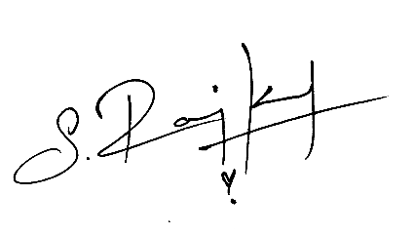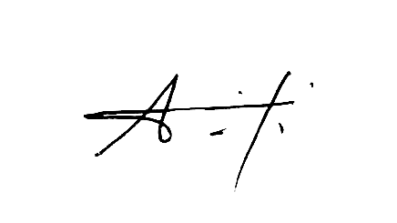

(Arjun Praveen) (Ranjith Karthik)